RESOLUTION NO.__________

RE: CERTIFICATE OF APPROPRIATENESS UNDER THE
PROVISIONS OF THE ACT OF THE PENNSYLVANIA
LEGISLATURE 1961, JUNE 13, P.L. 282 (53
SECTION 8004) AND BETHLEHEM ORDINANCE NO.
3952 AS AMENDED.

WHEREAS, it is proposed to reroof the front and rear porch at 236 E. Wall Street.

NOW, THEREFORE, BE IT RESOLVED by the Council of the City of Bethlehem that a Certificate of Appropriateness is hereby granted for the proposal.

Sponsored by: (s)

(s)

ADOPTED BY COUNCIL THIS DAY OF

(s)
President of Council

ATTEST:

(s)
City Clerk

HISTORICAL & ARCHITECTURAL REVIEW BOARD

The applicant proposes to reroof the porch at 236 E. Wall St.
APPLICATION #4:

Alley-Cade MacRae
236 E. Wall St., Bethlehem, PA 18018

OWNER:

__________________________________________________________________________

The Board upon motion by Marsha Fritz and seconded by Beth Starbuck adopted the proposal that City Council issue a Certificate of Appropriateness for the following:

- Re roof the front and rear porch with GAF Slateline shingles.

- The color is to be Antique Gray or equal.

3. Metal flashings to be copper and lead coated copper.

4. The motion was unanimously approved.

__________________________________________________________________________

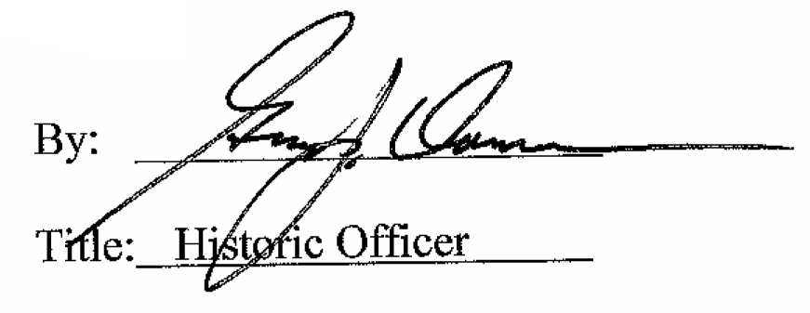

Date of Meeting: August 5, 2015

